**Intake results**

20. Number of members at group formation {0}, is this correct?

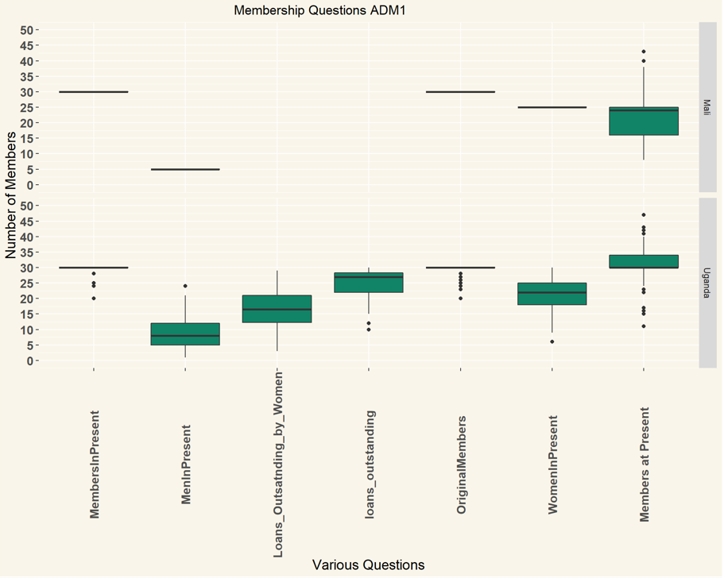

Questions & requests:

Red arrows

1. I don’t understand the labels “men in present” “women in present” and “members in present”. If this information came from the administrative data it should be labeled “men in group at start” / “women in group at start” etc.
2. Did you put here the data from administrative data or also the corrections from Q.20 in the interview?
3. Please put 3 data men/women/total group members next to each other in separate graph.

Blue arrows

Is that the information from the administrative data?

Green arrows

Is that the number of loans from administative data, previously uploaded? Or is it from current loans, if so which question?

Altogether, please split the information into 3 graphs and give each graph a clear title and clear reference where the information came from. Ideally, also indicate for each data what sample size (per country) is: n=120 or 151 or 149, etc

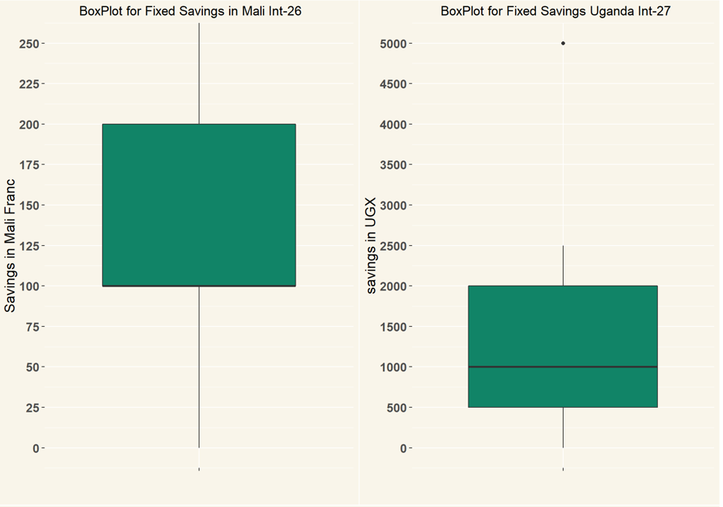

Please split this into two separate graphs. The Mali graph should have the title “What was the fixed savings amount during first cycle?” and the Uganda graph should have title “What was the share amount during first cycle?”

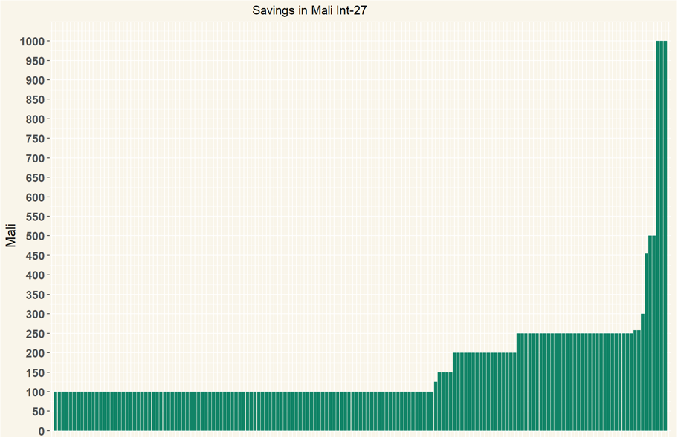

Please give this one the title “Fixed savings amount during first cycle, Mali” (It should be named Int-26 not 27)

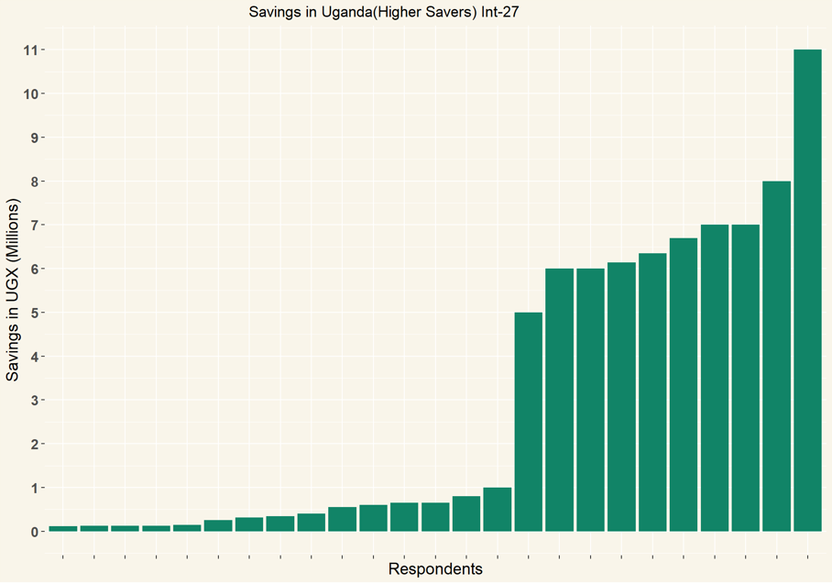

This should be titled “Share amount in Uganda during first cycle. Int-27 (high outliers)

[please note, i think this data is wrong and should be removed. There is no way that the share amount was 100,000, that would have been the total accumuulated savings or the researchers should be altogether confused. Could you send me the list of the researchers who got this amount and the names of hte groups where they wrote these high amounts?]

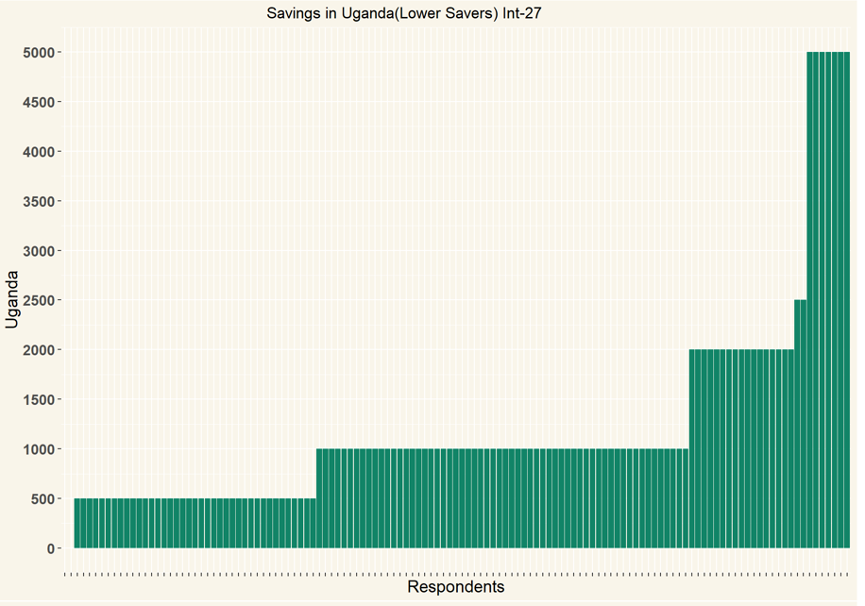

Please write as title: “Share amount during first cycle Int-27”. Please add n=....

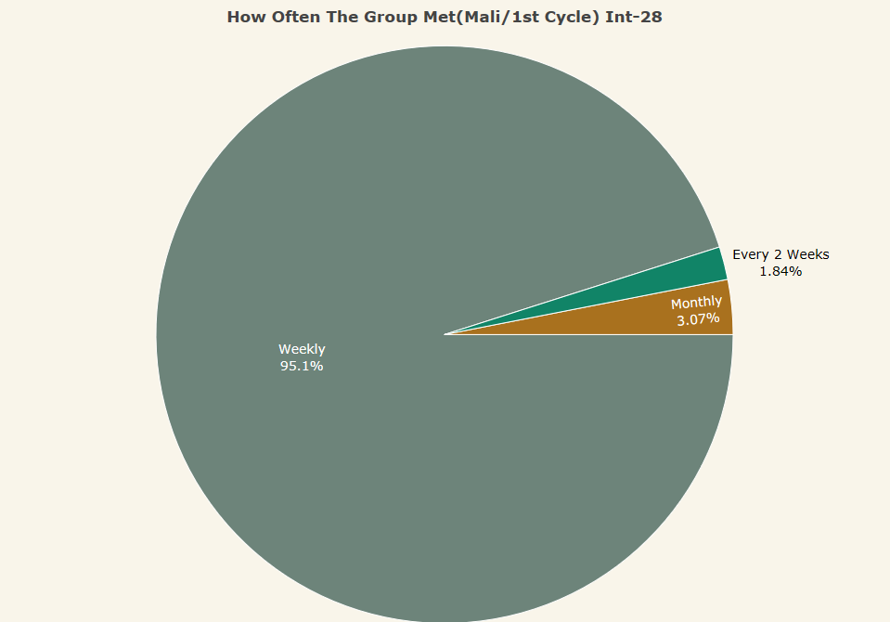

This is good! Please add n=....

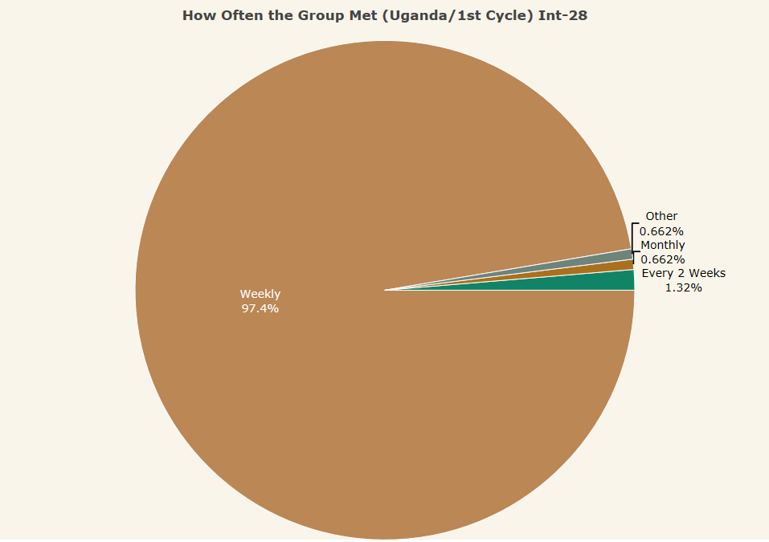

This is good! Please add n=....

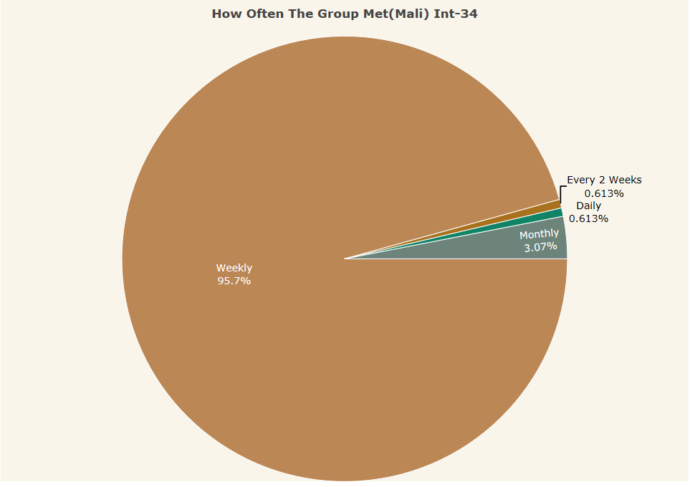

Please rephrase “How often does your group meet? (Mali) Int-34”

Please add n=....

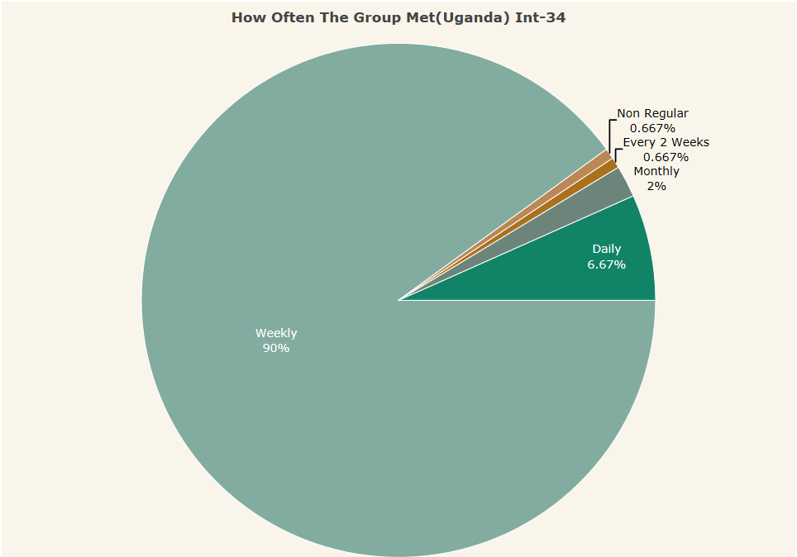

Please rephrase “How often does your group meet? (Uganda) Int-34”

Please add n=....

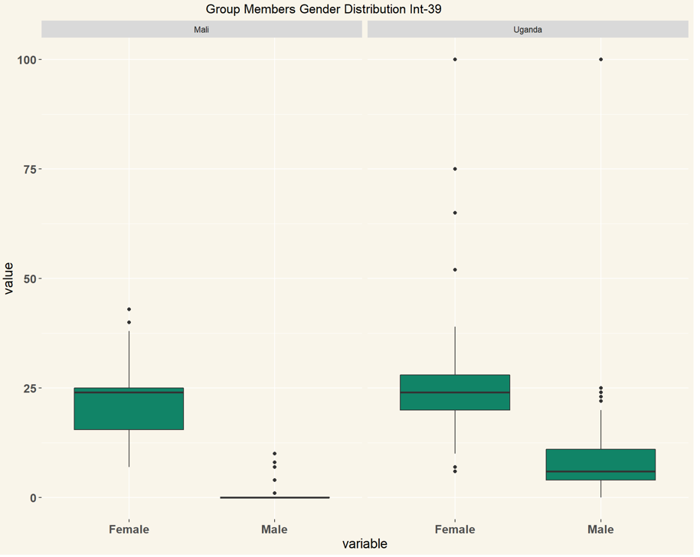

Please rename “Current group membership total and gender distribution”

Please add n=....

Please also add information from Int-38 which is total number of group members.

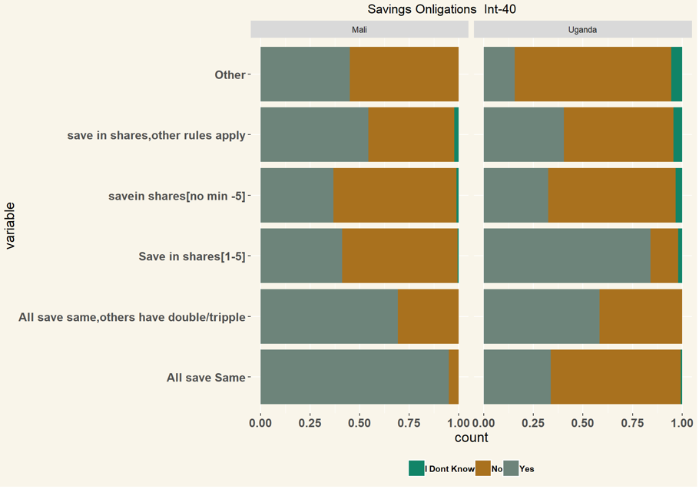

Please give title “What savings obligations do group members have?”

Add n= ....

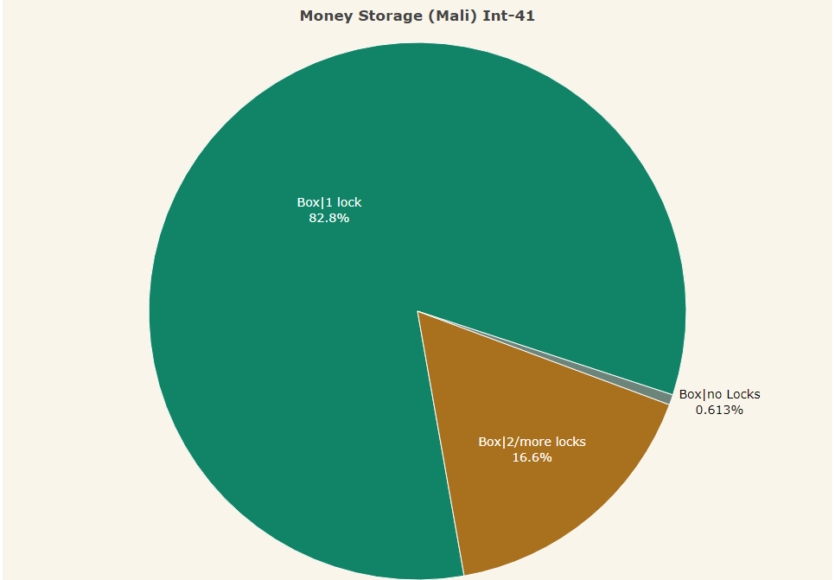

Please write in fulll “In between meetings, where does the group keep its cash?”

Please add n= ....

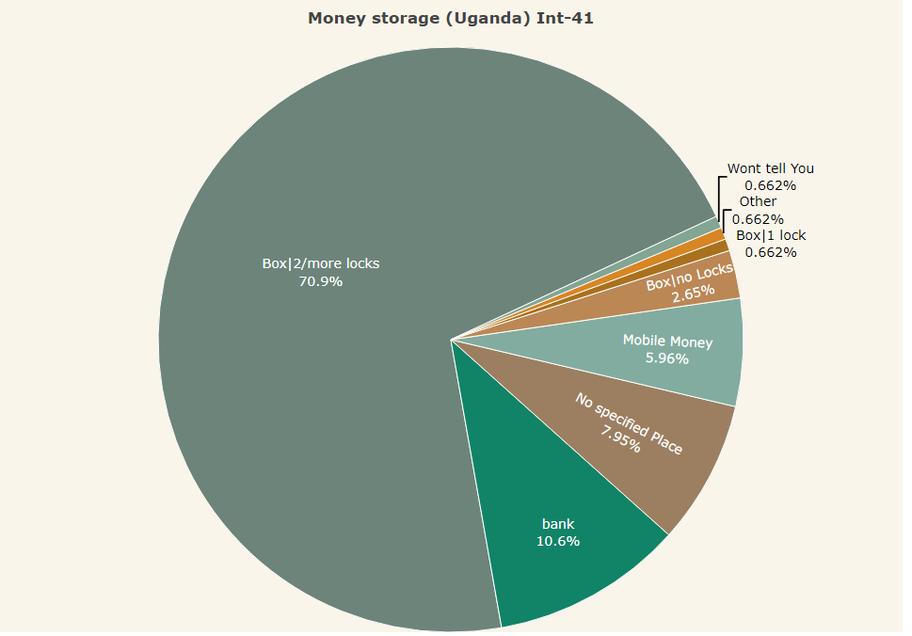

Please write in fulll “In between meetings, where does the group keep its cash?”

Please add n= ....

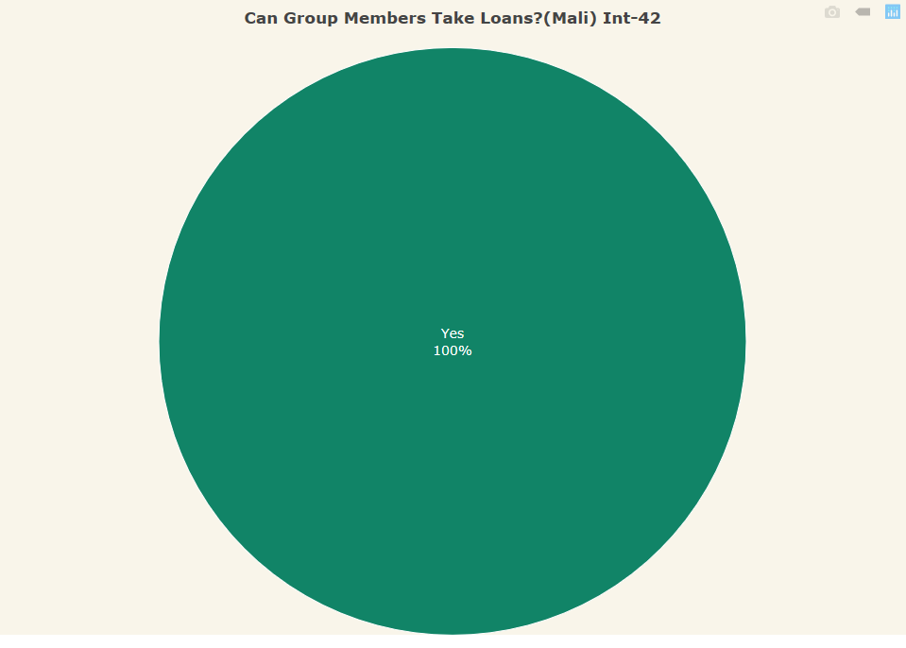

Perfect!. Just add n= ....

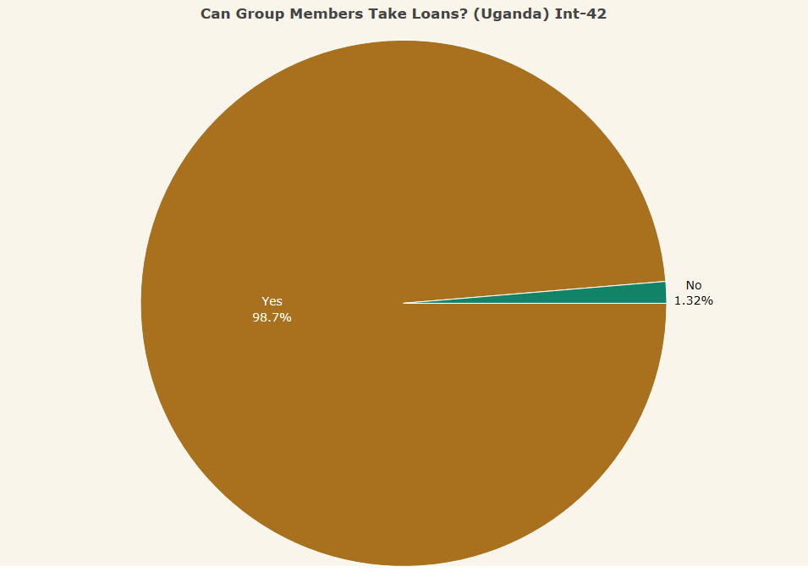

Perfect!. Just add n= ....

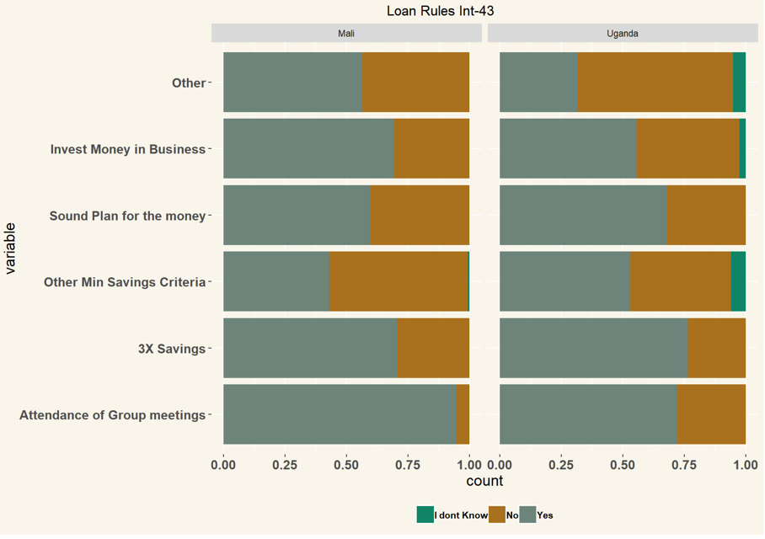

Please write in full “What rules apply for being eligible for a loan?”

Write n= ....

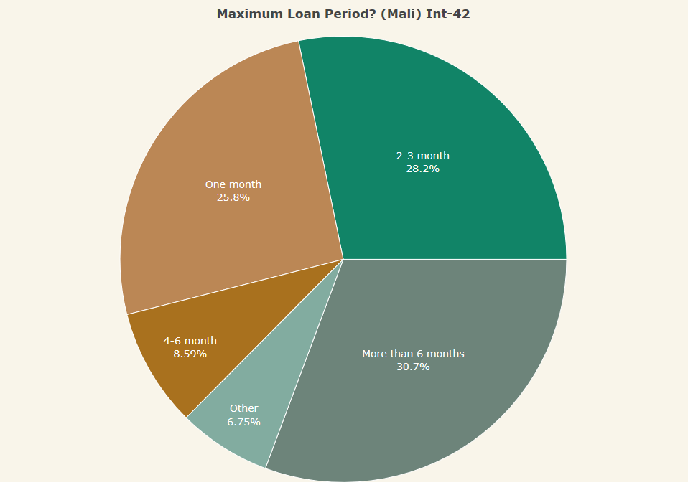

Perfect, please add n=....

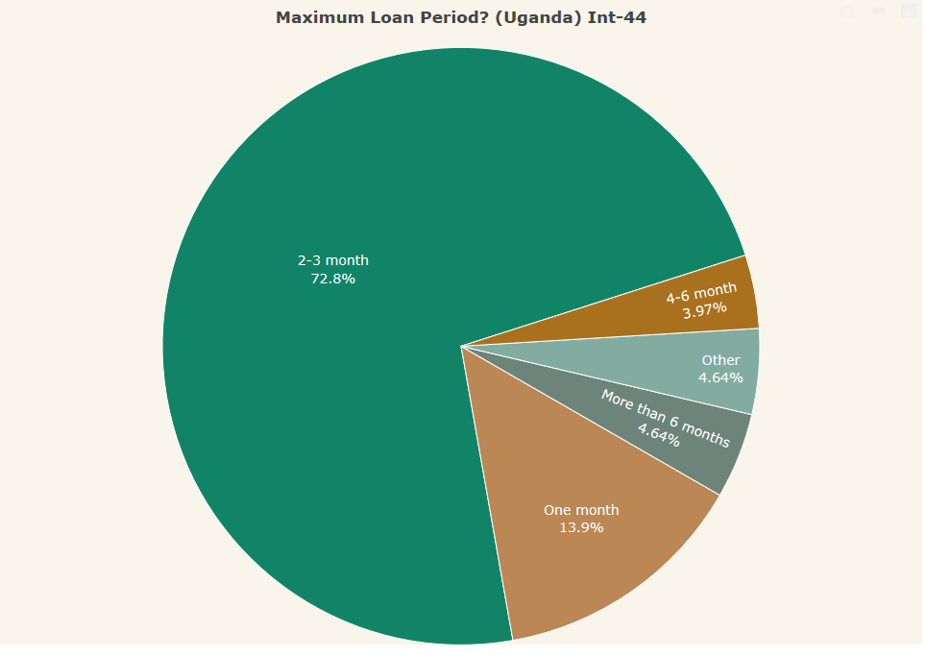

Perfect, please add n=....

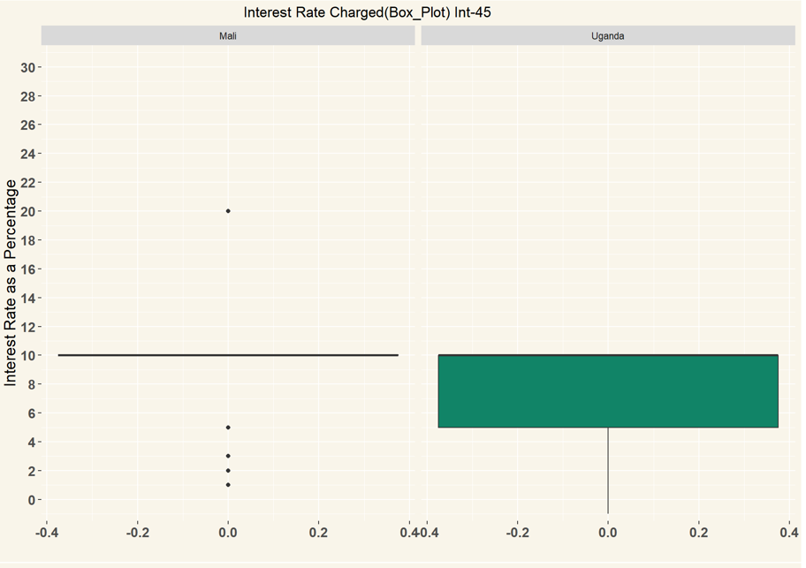

Perfect

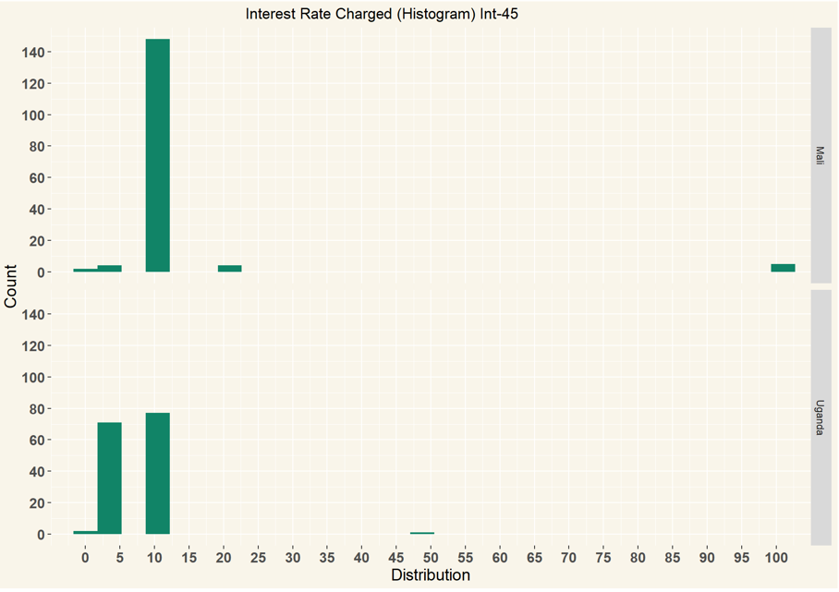

Perfect

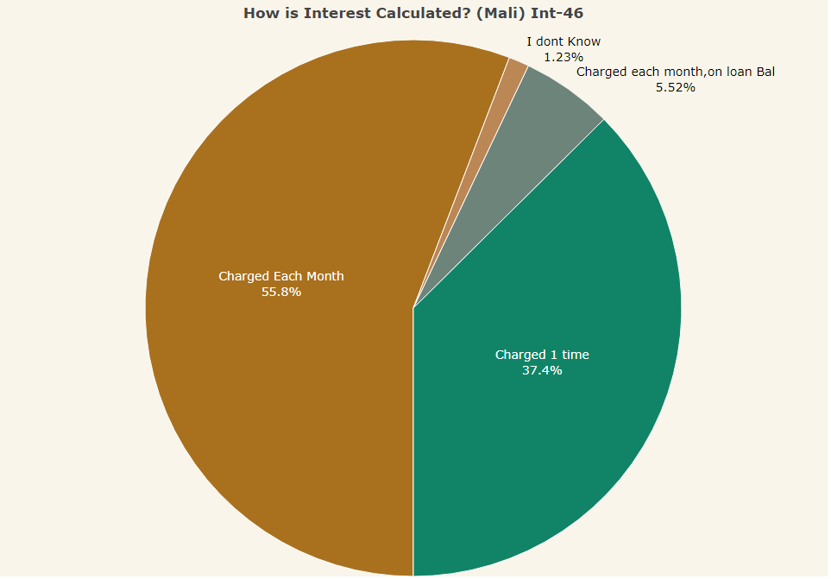

Perfect, please add n=....

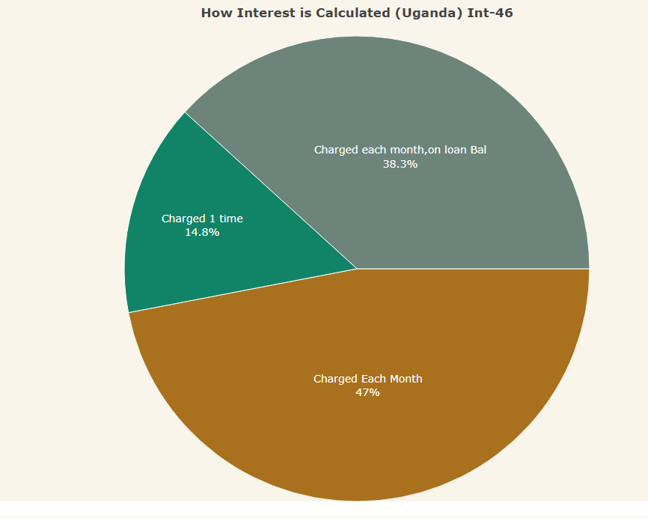

Perfect, please add n=....

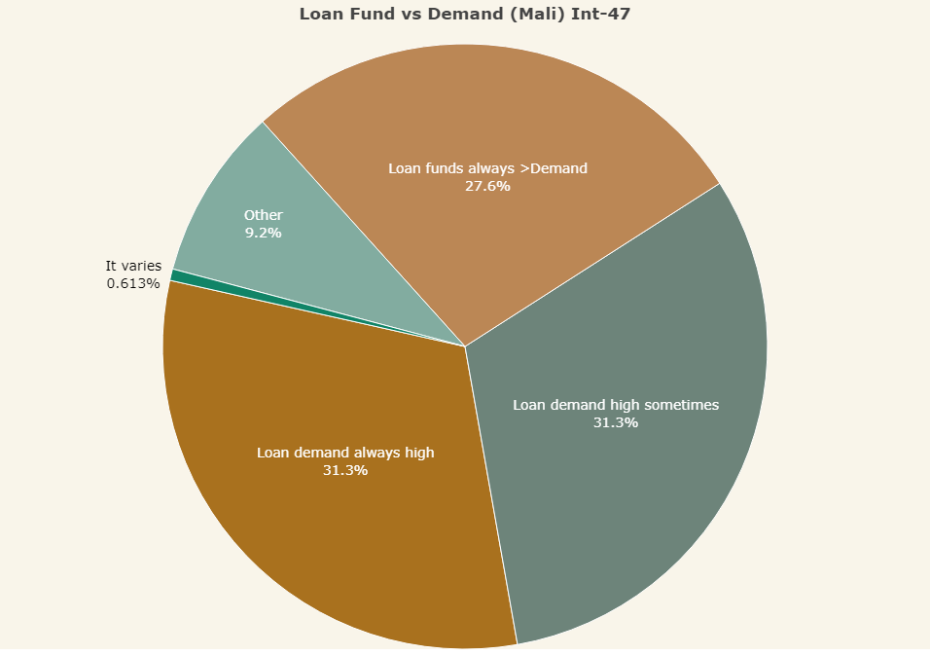

Better write the exact details of the answer categories. People may not fully understand the abbreviations.

There are always more people interested to take a loan than the available loan funds

There are sometimes more loan applications than available loan funds

There is always more available loan funds than the demand for loans

It varies, sometimes more funds, sometimes more loan applications

Other (specify)

I don’t know

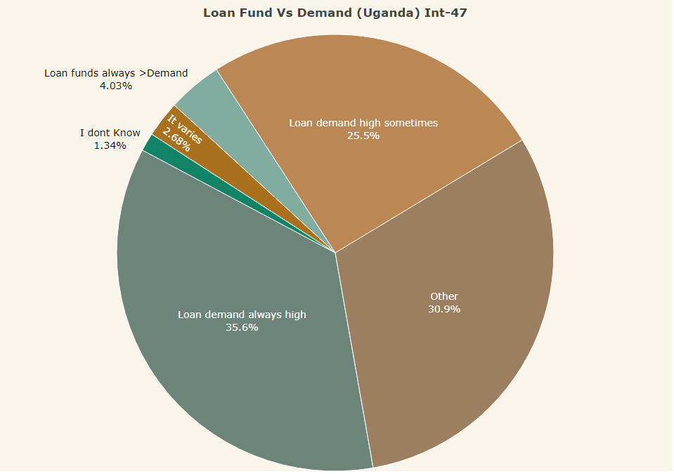

See comments above, Mali graph.

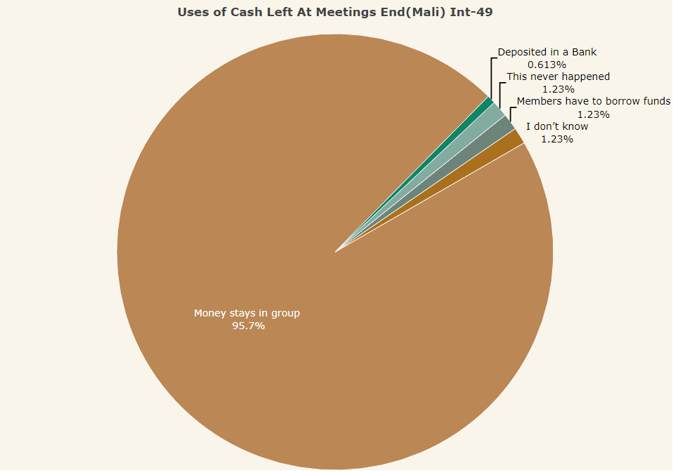

Please write question in full “If there is cash left over at the end of a meeting, what happens?”

Better write exactly the same answer categories.

The money stays in the group until next meeting

Members are obligated to borrow the money

The funds are deposited in a (bank-)account

Other (specify)

This situation has never happened

I don’t know

Please add n=....

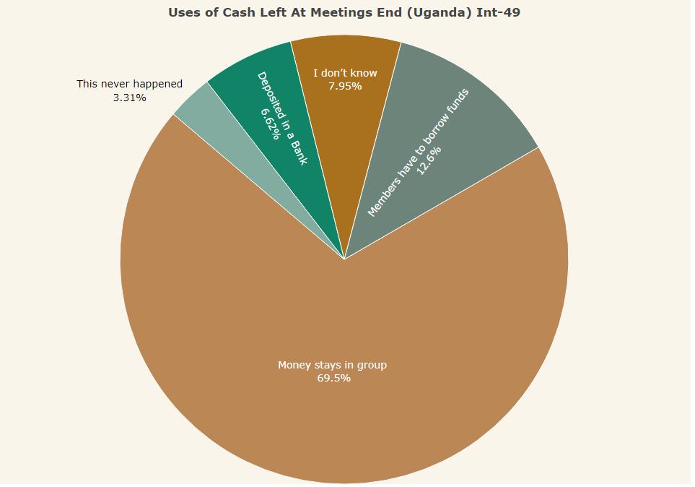

Please see comments for Mali graph.

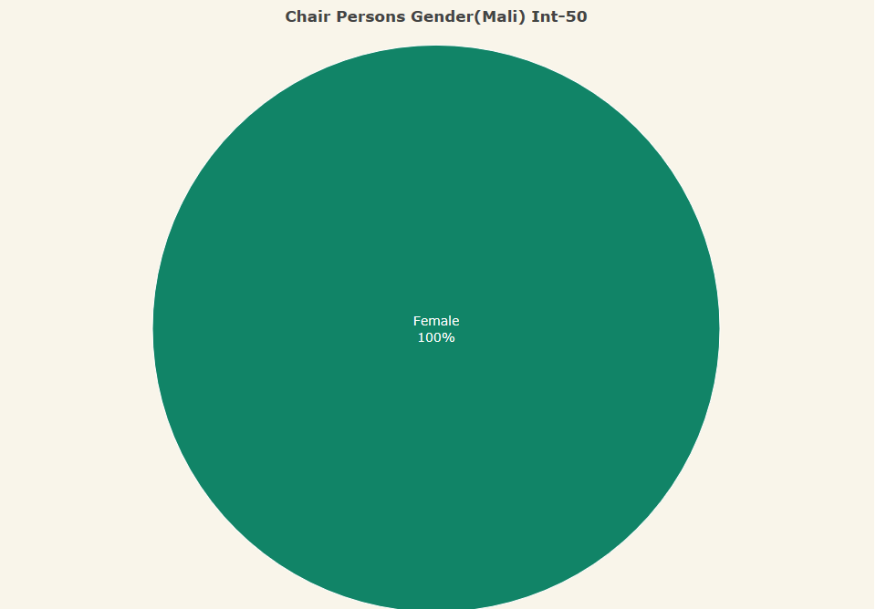

Please add n= ....

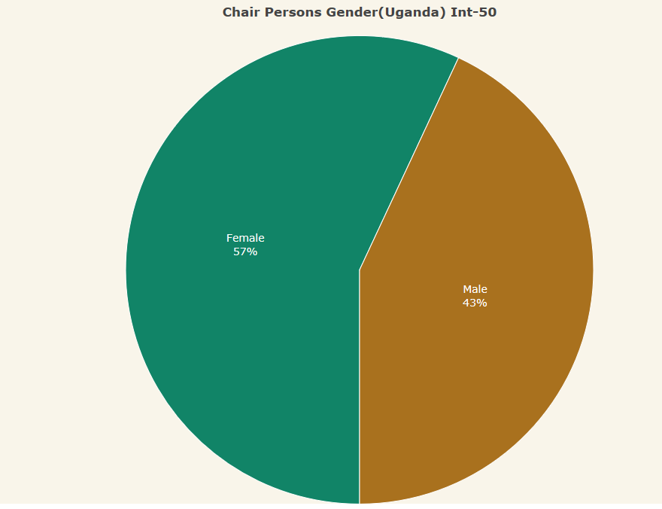

Please add n= ....

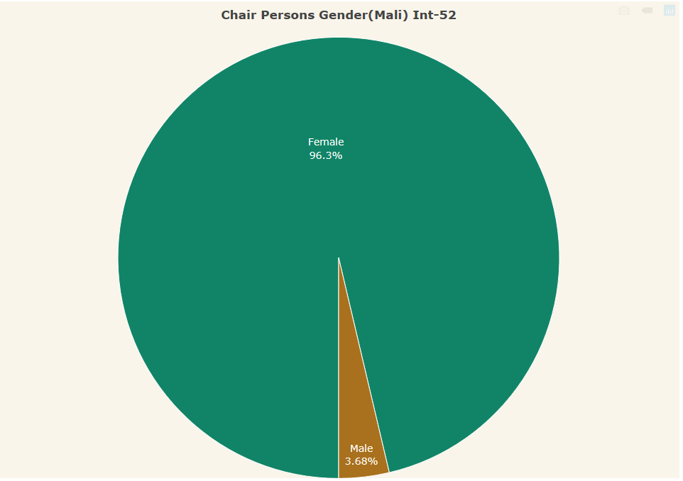

Title should change: “What is respondent’s gender?”

Please add n= ....

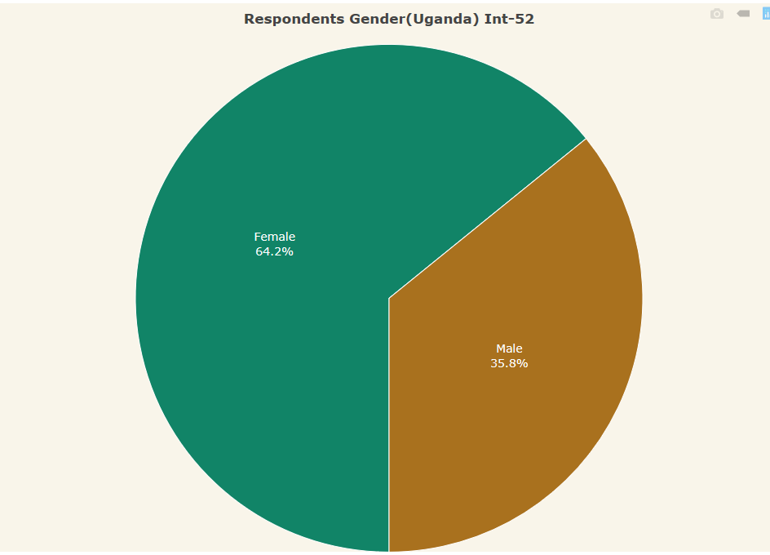

See above, Mali graph

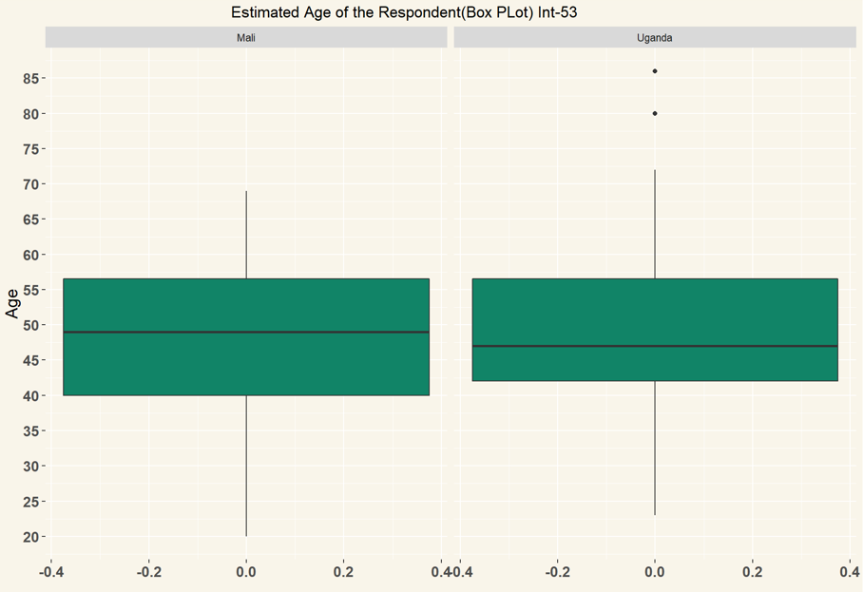

Perfect! Add n= ....

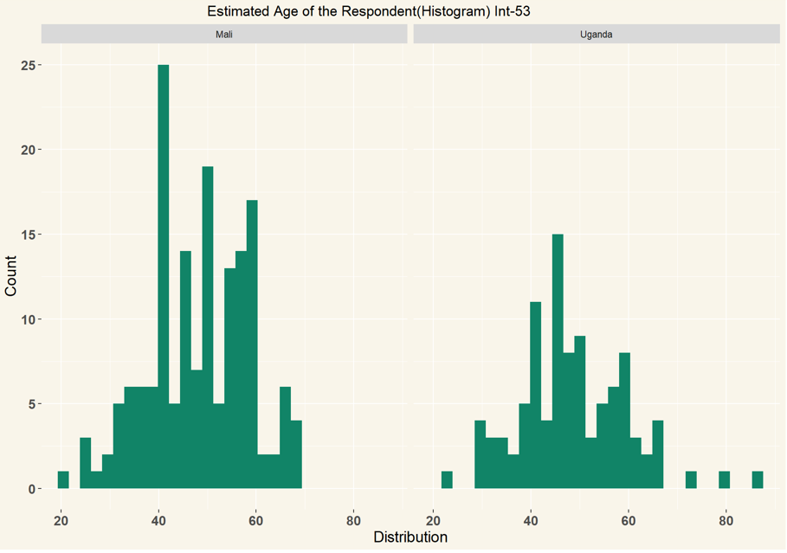

Perfect! Add n= ....

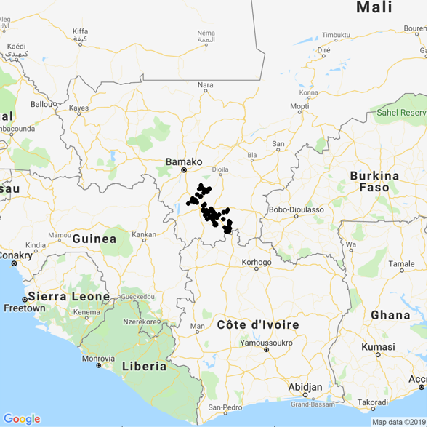

Very nice. Could you also make one which is zoomed in, say just Bamako to the north and Korhogo still just on it, nothing more?

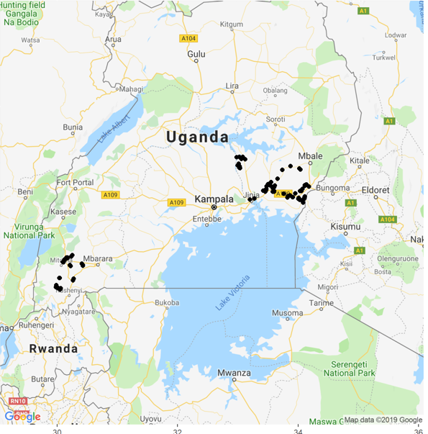

Very nice. Could you also make a zoomed in versions, one with just Western and one with just the Eastern fitting on.